**Assignment No.2**

Name: - Bhavin Ratansing Patil

Roll No.: - 26 SEDA

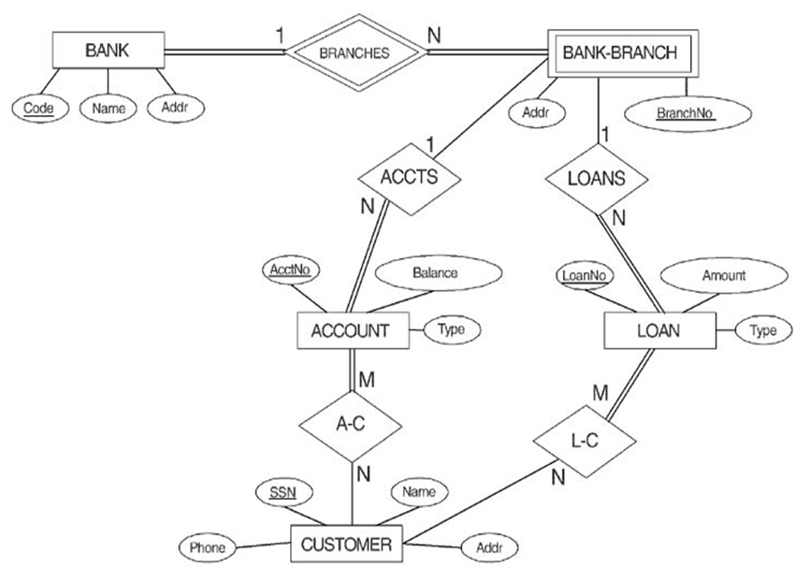**Que 1. Convert the ER diagram into Relational Schema**

**1.**



BANK (Code, Name, Addr)

BANK-BRANCH (Code, Branch_No, Addr)

ACCOUNT (AcctNo, Balance, Type, Code,BranchNo)

CUSTOMER (SSN, Name, Phone, Addr)

LOAN (LoanNo, Account, Type, Code,BranchNo)

AC (SSN, AcctNo)

LC (SSN, LoanNo)

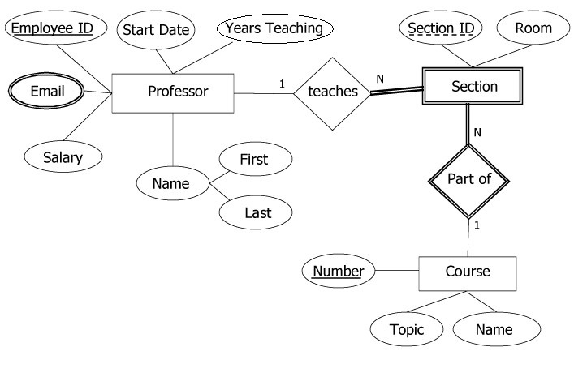

**2.**

🡪

PROFESSOR (EmployeeID, Salary, FirstName, LastName, Start Date, Years Teaching)

PROFESSOR_EMAIL (EmployeeID, Email)

COURSE (Number. Topic, Name)

SECTION (SectionID, Room, Number, EmployeeID)

**~~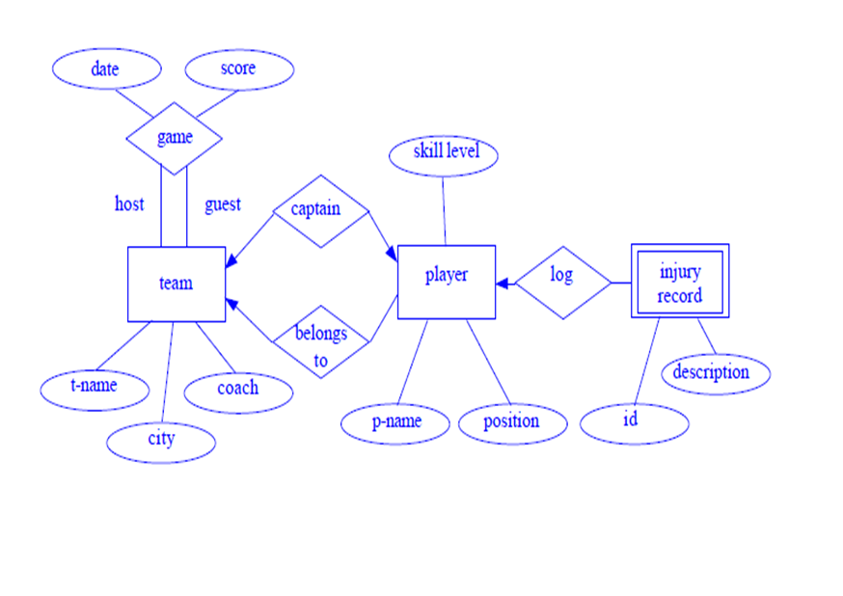~~ 3.**

🡪

TEAM (Tname, city, coach, gameDate, gameScore)

PLAYER (Pname, Position, Skill Level, Tname)

INJURY RECORD (ID, Description, Pname)

CAPTAIN (Pname, Tname)

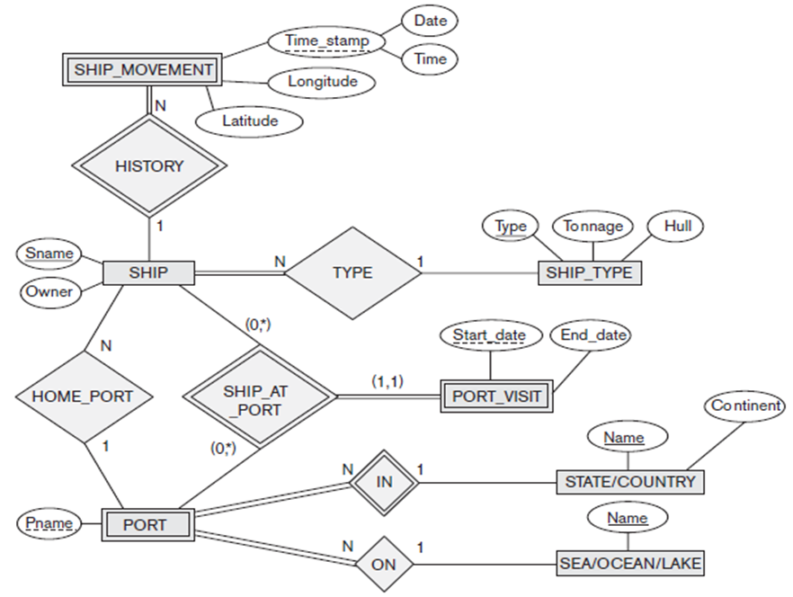 **4.**



SHIP (Sname, Owner, Type, Pname)

PORT (Pname, Name, Name)

SHIP_TYPE (Type, Tonnage, Hull)

PORT_VISIT (Start Date, End Date, Sname, Pname)

SHIP_AT_PORT (Sname, Pname)

STATE (Name, Continent)

SEA (Name)

SHIP_MOVEMENT (Sname, Date, Time, Latitude, Longitude)

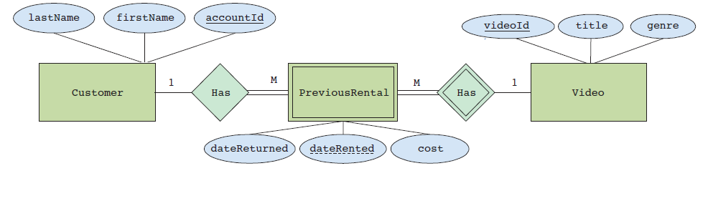**5. Based on the above E-R diagram, answer the following questions:**

1. Name the strong and weak entity sets.

* Strong Entity: - Customer and Video

Weak Entity: - PreviousRental

1. Which is the identifying entity set, primary key and discriminator for the weak entity set?

* Identifying Entity Set: - Has

Primary Key: - accountId

Discriminator: - Collection of Video ID, Title, Genre

1. Name entity sets with total and partial participation in the relationship set.

* Total Participation: - PreviousRental

Partial Participation: - Customer, Video

1. Draw relational schema diagram.

CUSTOMER (AccountID, Lastname, Firstname)

VIDEO (VideoID, Title, Genre)

PREVIOUSRENTAL (DateRented, AccountID, VideoID, DateReturned, Cost)

**6. Map the relational schema in Figure into an ER schema**

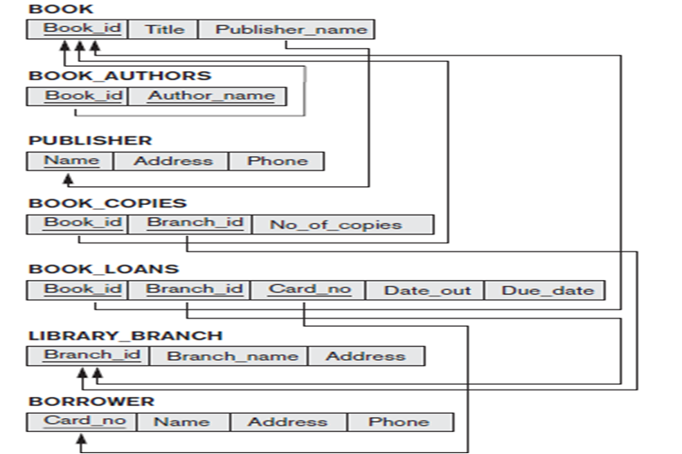s

